*Uses linear programming to mathematically formulate the problem and uses Excel solver and sensitivity analysis to optimize profits*

**Project**

**5**

P5

ALY6050 Intro to Enterprise Analytics

Project 5 – Using Linear Programming Models to Maximize Profits

**PREPERATION:**

By: John DiSessa

For: Professor Behboudi

On: March 27th, 2022

Introduction

We were tasked with maximizing the monthly profit of an appliances company who is planning to open a new distribution center. Their two main concerns were their monthly purchasing budget and their available warehouse space. Given certain purchasing, inventory, and warehouse constraints, we optimized the monthly purchase amounts of their four products (Refrigerators, Dishwashers, Water Heaters, and Pressure Washers) to maximize profit.

Analysis

**Constraints**

The first metric we had to calculate was the profit margin on each unit. Based on the given costs and selling prices, we expect the company to make $430.40 on each refrigerator, $200.40 on each dishwasher, $272.40 on each water heater, and $214.34 on each pressure washer. Since our goal was to maximize monthly profit (Z), we used linear programming to optimize the following equation: $Z=(430.4*X1)+(200.4*X2)+(272.4*X3)+(214.34*X4)$. X1, X2, X3, and X4 are the amount of each product the company purchases each month. Our calculations will provide the optimal values for each product that maximizes profit.

|  |  |  |  |  |
| --- | --- | --- | --- | --- |
| **Unit** | **Product** | **Cost** | **Selling Price** | **Profit Margin** |
| X1 | Refrigerator | $ 869.59 | $ 1,299.99 | $ 430.40 |
| X2 | Dishwasher | $ 459.59 | $ 659.99 | $ 200.40 |
| X3 | Water Heater | $ 357.59 | $ 629.99 | $ 272.40 |
| X4 | Pressure Washers | $ 155.65 | $ 369.99 | $ 214.34 |

However, we also had to consider the storage requirements for each item as well. Even though refrigerators are the most profitable products, they also take up the most space in the warehouse. Each refrigerator takes up 25 sqft. Each dishwasher can be stored on half of an 8x5 pallet so each dishwasher takes up 20 sqft. Each water heater can be stored on a third of a 9x5 pallet so each water heater takes up 15 sqft. A 5x5 pallet stores two cases of four pressure washers each so each pressure washer takes up 3.125 sqft. The warehouse would contain 5100 total sqft, however there needs to be at least 300 sqft of empty space so that there is room to maneuver in the warehouse and ensure adequate spacing between each pallet.

|  |  |  |  |
| --- | --- | --- | --- |
| **Product** | **Pallet** | **Total SqFt** | **SqFt per Item** |
| Refrigerator | 5x5 | 25 | 25 |
| Dishwashers (2) | 8x5 | 40 | 20 |
| Water heaters (3) | 9x5 | 45 | 15 |
| Pressure Washers (8) | 5x5 | 25 | 3.125 |

We also considered additional constraints that the company mandated. At most, 70% of the total inventory at any given time can be made up of water heaters and pressure washers. Also, there must always be twice as many water heaters as pressure washers. Additionally, the purchase amounts of each product must be whole numbers and nonnegative since they can’t purchase partial units or purchase a negative number of units. Also, the company has a given monthly purchasing budget of $150,000. All of the constraints are summarized in the following table.

|  |  |  |  |
| --- | --- | --- | --- |
| **Type** | **Constraint LHS** | **Sign** | **Constraint RHS** |
| Purchasing | =(869.59*X1)+(459.59*X2)+(357.59*X3)+(155.65*X4) | ≤ | 150000 |
| Inventory | =(2*X4)-X3 | ≤ | 0 |
| Inventory | =-.7X1+-.7X2+.3X3+.3X4 | ≤ | 0 |
| Warehouse | =(25*X1)+(20*X2)+(15*X3)+(3.125*X4) | ≤ | 4800 |
| Nonnegativity | X1,X2,X3,X4 | ≥ | 0 |
| Integer | X1,X2,X3,X4 | = | Integers |

**Optimal Solution**

Based on all of the previous criteria, we obtained an optimal maximum monthly profit of $95,305.22 using Excel Solver. The company could achieve this if they purchased 25 refrigerators, 0 dishwashers, 146 water heaters, and 73 pressure washers each month and sold all of them.

|  |  |  |
| --- | --- | --- |
| **Solver Solution** | **Units** | **Monthly Profit** |
| Refrigerator | 95 | $40,888.00 |
| Dishwashers | 0 | $0.00 |
| Water Heaters | 146 | $39,770.40 |
| Pressure Washers | 73 | $15,646.82 |

**Sensitivity Analysis**

In addition to calculating the optimal solution, we also ran sensitivity analysis in order to see how parameter changes will affect the optimal solution. For example, what is interesting to note is that the company should not purchase or sell any dishwashers. They are the least profitable product despite taking up the second most square feet of any product. The following sensitivity report shows us the allowable increase and decrease in each coefficient (per unit profit). If we kept every variable the same, but increased our profit margin on dishwashers to more than $329.85, the optimal solution would change. If we increased our profit margin to $329.86, the optimal solution would be to buy 18 refrigerators, 85 dishwashers, 160 water heaters, and 80 pressure washers for a maximum monthly profit of $96,516.50. However, it is important to note that the Excel Solver sensitivity analysis does not allow us to use the integer constraint so our sensitivity analysis only contains approximations. We continued our sensitivity analysis by calculating our slack variables from our optimal solutions. Even though the company had a monthly purchasing budget of $150,000, the optimal solution has them spending only $146,181.64 (the sensitivity analysis shows $146,267.78 since solver’s sensitivity analysis does not allow us to use the integer constraint).

The difference between our maximum and actual monthly purchasing is our slack of $3,818.36. The company could decrease their purchasing budget by this amount and still obtain the same optimal solution. We can also see the allowable increase of 1E+30 for our purchasing budget. This is incredibly large value so we can assume this to be infinity. The company could increase their monthly purchasing budget by an unlimited amount and, due to the other constraints, would still obtain the same solution.

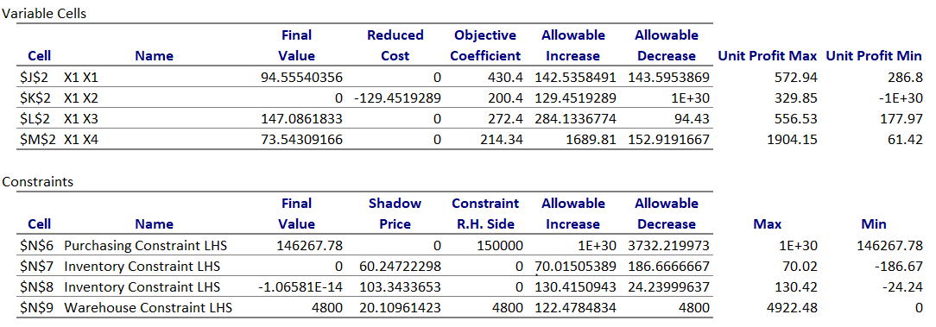

It seems as though the warehouse constraint is the constraint that is bottlenecking our solution and preventing the company from increasing their monthly profits. The optimal solution has the company using 4,793.15 available sqft in the warehouse (non-integer analysis shows all 4800 sqft being utilized). With an allowable increase of 122.48, they could increase the size of the warehouse to 4,922.48 sqft and still obtain the same solution. However, if the company kept all variables the same but rented a larger warehouse of 6,334 sqft (with 6,034 sqft of usable space) they would increase their monthly profit to $104,157.48. We ran many sensitivity analyses with varying warehouses sizes but anything more than 6,334 sqft resulted in wasted space. With a warehouse that size, it would be optimal to purchase 0 refrigerators, 132 dishwashers, 205 water heaters, and 102 pressure washers. Even though refrigerators are the most profitable, the increased space allows significantly more dishwashers to be stored. Assuming all products would be sold, increasing the warehouse from 5,100 sqft to 6,334 sqft (1,234 increase) would result in a profit increase from $95,305.22 to $104,157.48 ($8,852.26 increase). If the company could increase the size of the warehouse for less than $8,852.26, they would be more profitable than with a 5,100 sqft warehouse.

|  |  |  |
| --- | --- | --- |
| **Solver Solution** | **Units** | **Monthly Profit** |
| Refrigerator | 0 | $0.00 |
| Dishwashers | 132 | $26,452.80 |
| Water Heaters | 205 | $55,842 |
| Pressure Washers | 102 | $21,862.68 |

Summary

Given the costs, selling prices, and various business constraints, we were successfully able to find the optimal purchase levels for each product that maximized monthly profit for the appliance company. The optimal product levels of 95 refrigerators, 0 dishwashers, 146 water heaters, and 73 pressure washers would generate $95,305.22 and only use $146,181.64 out of the $150,000 monthly purchasing budget. Therefore, the $3,818.36 should be reallocated or saved. The problem with this solution is that it removes dishwashers from company product offerings. Mathematically it is more optimal that way, however realistically, customers would be disappointed in an appliance company that does not offer one of the most essential home appliances. If the company found a way to decrease costs or increase the selling price of their dishwashers to achieve a profit margin of more than $329.85, approximately, the optimal solution would be to buy 18 refrigerators, 85 dishwashers, 160 water heaters, and 80 pressure washers for a maximum monthly profit of $96,516.50. Not only does this mean the company would have a diverse set of offerings, but their monthly profit would increase too. If the company would accept removing one of their four offerings, then upgrading to a warehouse of 6,334 sqft would result in the highest possible profit if all profit margins remained the same. They would make $104,157.48 per month with inventory levels of 0 refrigerators, 132 dishwashers, 205 water heaters, and 102 pressure washers.